App Title Suggestion: **Flow: VOice Notes Social Media**App Title Suggestion for IOS: **Flow: VOice Notes Social Media**Subtitle for IOS: **RECORD & POST AUDIO MEMORIES**Added few relevant high traffic keywords in the title extension and subtitle for higher visibility on Stores.

**Keywords Set**network,friends,family,rooms,newsfeed,apps,new,recorder,conversation,like,chat,listen,story,trending

**Meta Tags for Google Play**

Meet New People

Social

Music and Audio

Dating

Entertainment

**Tips and Suggestions**

* Add preview videos (30seconds) to increase conversion.
* Get few 5 star reviews with targeted keywords mentioned in them.
* Create few backlinks of the app on relevant forums and guest blogs.
* Share the app link on Social media groups and Pages timeline.
* Do Store Localization to spread app for all languages
* Running a paid promotion in the second week of new ASO gives a boost.

**Key phrases to target in description**BELOW ARE THE CAREFULLY SELECTED KEYWORDS WITH THEIR TRAFFIC SCORE AND DIFFICULTY ON GOOGLE PLAY STORE.

* FLOW – Voice Notes Social Media
* Audio Social Network
* New Social Apps
* Audio Rooms
* Record Voice Memories
* Voice Social
* Voice Chat
* Voice Posts
* Audio Conversations

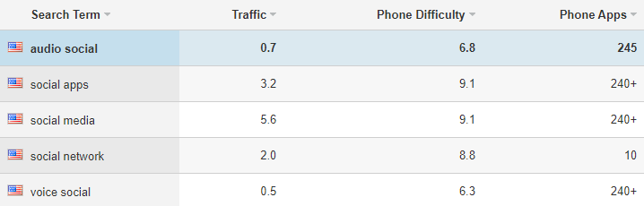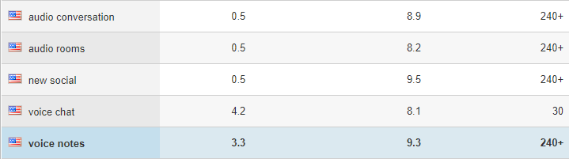

**Short Description**

Record voice memories & share voice posts in audio format social network app.

**Promo Text**

Share voice posts, record voice memories and join audio rooms to connect audible on audio social network app. Share voice social posts to be heard by others.

**Long Description**

Do you want to be heard by your social community? How about changing the way you socialize with the help of recording and posting voice chat on audio social network? Whether you want to share voice posts to be heard by others or you want to record voice memories and share them online to change the way you socialize in audio rooms, this audio social network app is the perfect place to start. Introducing FLOW, the app to be heard. Post voice social notes and join the FLOW community. Participate in audio conversations from other members and follow voice posts from your most-liked members on one of the most exciting, new social apps available for your smartphone. Unlike other social apps, this voice social platform lets you voice chat with new followers or follow the accounts you like to stay in touch audibly.

**Record Your Flows - Voice Posts of 15 Seconds**

A flow is a voice note of 15 seconds maximum. Get creative and original with the voice posts that you share with others. Record voice memories or share voice social posts with interesting things from your knowledge and routine. Participate in audio conversations and let others hear you without getting bored on this audio social network app. As one of the new social apps, this platform changes the way you socialize and connect with others!

**Record Voice Memories and Share With Others**

Be yourself, record voice memories and share voice chat with others. In your voice posts, you can add cool audio filters and customize your voice chat with text or images that you like. Make audio conversations fun and exciting for all with this new voice social app.

**Follow Voice Social Network Members You Like**

Join audio rooms and share voice posts on this audio social network. Keep in touch with voice social members and become a part of cool audio conversations. Participate in Audio Conversations via Voice Chat and share whatever you like!

**Features of FLOW – Voice Notes Social Media:**

■ Record 15 seconds flow voice posts from anywhere in the app in just seconds.  
■ Personalize your voice chat flow with the addition of images and audio filters that are always fun!  
■ Subscribe to voice social content creators you like and grow your community.  
■ Add a flow in a story that will disappear after 24 hours. You and your followers can react to it by voice.  
■ Browse your personalized news feed, regularly updated for more content to listen to, like, comment on and share with your friends!  
■ Discover the hottest flows and audio conversations of the moment in the explore tab. You'll be able to find all kinds of content categories: music, humor, sports, cooking and many more!  
■ Exciting new social apps to record voice memories and join interactive audio rooms

■ Join audio social network and grow your interaction via voice social

Download FLOW – Voice Notes Social Media and unleash your creativity!

*If you have any comments, contact us at support@flowappweb.com or tweet us @FlowEntreprise

**Keywords Density**

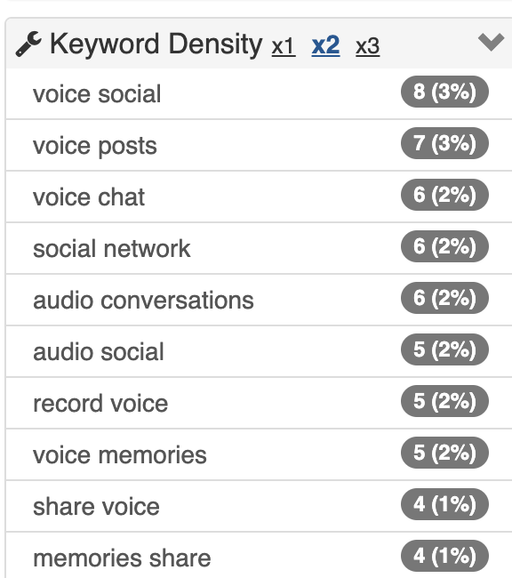

**App should rank on combination of following keywords on apple appstore**



